TASK 1
struct Address {
var city: String?
}
struct User {
var name: String
var age: Int?
var address: Address?
}
func describe(_ user: User) -> String {
guard let age = user.age else {
return "Age unknown"
}
let city = user.address?.city ?? "unknown city"
return "\(user.name), Age: \(age), City: \(city)"
}
let u1 = User(name: "Anu", age: 20, address: Address(city: "Chennai"))
let u2 = User(name: "Ben", age: nil, address: nil)
let u3 = User(name: "Dev", age: 21, address: Address(city: nil))
print(describe(u1))
print(describe(u2))
print(describe(u3))
print(Int("42") as Any)
print(Int("abc") as Any)
OUTPUT:
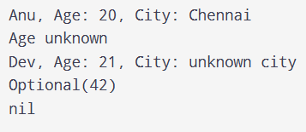
TASK 2
let values = ["10", "x", "25", "", "7.5", "40"]

let numbers = values.compactMap { Int($0) }

print(numbers)
print(numbers.reduce(0, +))
print(values.count - numbers.count)

let doubled = numbers.first.map { $0 * 2 }
print(doubled as Any)

OUTPUT:
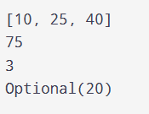

TASK 3
let scores = ["Asha": 90, "Ravi": 72]
if let kiran = scores["Kiran"], let number = Int("12a") {
print(kiran + number)
} else {
print("Missing score or invalid number")
}
OUTPUT:
